Lesson plan 1: Introduction to the Scratch environment and sequencing
About the lesson
This lesson introduces students to the Scratch environment. They will learn what the different areas of the environment are and how to construct and run a basic program using sequencing. They will then apply this knowledge and understanding to solve some basic problems using sequencing.
Learning objectives
By the end of this lesson, students will know how to:
- define sequencing
- use sequencing in a program
- construct a working program to solve a problem.
National Curriculum
The following subject content from the KS3 National Curriculum is included in this lesson:
- Use two or more programming languages, at least one of which is textual, to solve a variety of computational problems.
Links
There are links to English and the need for precise instructions that are carried out in order. There are also links to maths and the internal angles of shapes.
Key terminology
programming construct, sequencing
Teaching and learning activities
Share the objectives for the lesson with students (Slide 2 of Lesson 1 presentation).
Starter
Ask students to write down a sequence of instructions to move a car around a track (Slide 3).
- Students could write the instructions on paper, on a word-processed document, or on a mini whiteboard.
- The idea of the starter is to encourage students to think about the importance of putting instructions in a logical sequence.

Answers
Move 3 squares forward
Turn 90 degrees right
Move 2 squares forward
Turn 90 degrees right
Move 2 squares forward
Turn 90 degrees right
Move 1 square forward
Turn 90 degrees left
Move 1 square forward
Ask: Does 'Move 3' mean the same as 'Move 3 squares forward'? Why?/Why not?
No. When programming you must use the instructions the computer understands. We can look at the instructions, interpret them and work out that they mean the same thing, but a computer cannot.
Ask: Does it matter what order the instructions are in? Why?/Why not?
Yes. If the instructions are in the wrong order, the car may not end up where you want it to end up. In another scenario, some instructions may be dependent on other instructions being completed before it.
Part 1
Explain the three programming constructs, what they are and why they are important (Slide 4).
The three programming constructs underpin our ability to solve problems, and throughout this module, students will be using Scratch to demonstrate their understanding of these concepts.
- Sequencing is when a set of instructions is carried out in order.
- Selection takes place when a program needs to make a decision. Depending on the outcome of that decision, the program will do one thing or another. In programming, selection can be easy to spot because it comes in the form of an if statement. You can also link this back to spreadsheets; an if statement in spreadsheets software is the same thing.
- Iteration is when a set of instructions is repeated. It is used when a program needs to complete the same process multiple times. Iteration can also be referred to as using a loop. You can spot a loop in a Scratch program because it will use a 'repeat' block.
Explain what sequencing is and ask students to identify the problems with a sequence of instructions (Slide 5 and page 42).
Students should write down their thoughts or you could use questioning to find out if they have identified all the problems. Possible questions to ask are:
- Is there a problem with the order of the instructions? If so, where?
- (Answer: Yes, there is a problem with the order of the instructions. The total cannot be calculated before the numbers are entered.)
- Does it matter that the numbers are entered in the order 1, 3, 2? Why/Why not? (Answer: No, as long as the three numbers are entered before the calculations take place, it doesn’t matter what order they are entered in.)
- Which instructions must happen before others can be completed?
(Answer: The numbers must be input before the total can be calculated. The total must be calculated before the mean can be calculated. The mean must be calculated before it can be displayed.)
Part 2
Explain what Scratch is and the different parts of the Scratch environment (Slide 6 and page 42, plus Video 1.1).
Ask students to complete Activity 1.1: Your first Scratch program (Slide 7, page 42/Worksheet 1.1, plus Evidence document 1).
Students are asked to save their programs. Depending on the browser you are using, students may be asked where they want to save their program, or they may be downloaded automatically. Make sure you know which option students will be confronted with and guide them accordingly.
Part 3
Explain what the pen extension does and introduce student to the blocks they will need to use in the rest of the lesson (Slide 8).
What each block in the presentation does is described in Activity 1.2.
Ask students to complete Activity 1.2: Using the pen to draw shapes (Slide 9, page 43/Worksheet 1.2, plus Evidence document 1).
Ask students to complete Activity 1.3: Drawing a square (Page 43/Worksheet 1.3, plus Evidence document 1 and Slide 10).
There are GIFs in the presentation to show students what should happen when they run their programs. Encourage students to decompose the problems (break the problems down) before trying to program them. Instead of thinking 'I need to draw a square', encourage them to break the problem down further and think 'I need to draw a line. Then I need to turn 90 degrees.' and so on. The activity contains two extension activities.
Answers
(See screenshot below and Activity 1.3 solution)
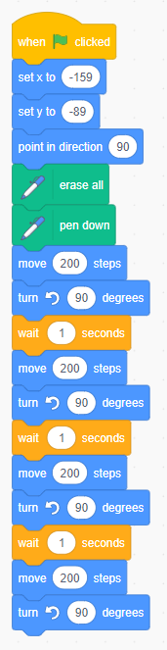

Extension activity 1
(See screenshot below and Activity 1.3 Extension 1 solution)
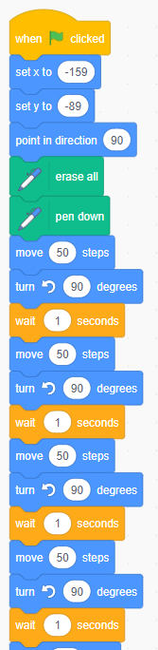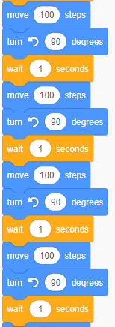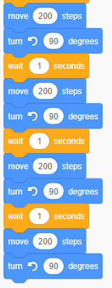

Extension activity 2
(See screenshot below and Activity 1.3 Extension 2 solution)
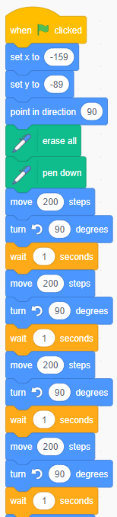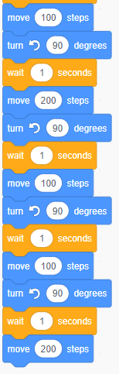

Plenary
Check students' knowledge and understanding with a short question and answer session linked to the learning objectives for the lesson (Slide 11–15).
- What is sequencing?
(Example answer: When a set of instructions is carried out in order.)
- What is the name of the area in Scratch where you can view your program running? (Answer: the stage)
- In which category would you find the block to change direction?
(Answer: Motion, the blue category)
- What would the following code do? (Slide 14)
(Answer: It would draw three lines with a gap in between them, e.g. - - -)
- What would the following code do? (Slide 15)
(Answer: It would draw the letter 'L'.)
Homework
Ask students to complete any activities they did not finish during the lesson.
Ask students to complete Quiz 1.
Stretch activities
Some students will complete the activities in this lesson quickly. They could be encouraged to try to draw other regular shapes with an increasing number of sides. They may be able to work out or research the internal angle needed for each shape. They may also explore using iteration to reduce the number of instructions required.
Support activities
Students who find it hard to write precise instructions may benefit from completing the Marching Orders activity from CS unplugged (https://csunplugged.org/en/).
Students who struggle to use the correct angles may benefit from increasing the length of the ‘wait’ between each set of blocks, to give them additional time to work out what may be wrong with their code. Drawing the shape onto paper using a pencil, ruler and protractor may help them to understand the angles required, and the steps involved in completing the shape.
A series of videos about drawing shapes in Scratch can be found at: www.youtube.com/channel/UCzyj8fEcs3AFDjMl91PlkxQ.

